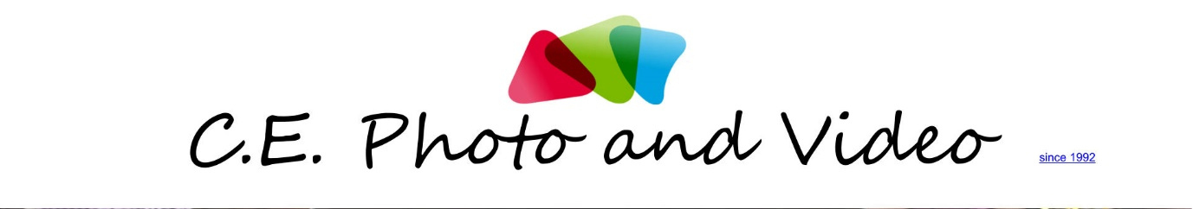

Free Photo / Video lesson
See web for T&C www.cephotography.com.au
Name:
Age:
Current education:
Availability (days / times):

What genre / style would you like to learn:

what do you prefer to learn (photo / video or both)?
Photo

Video

Any additional information here:

Office use only:

